Bash Scripting Task 2

1 . Create a bash script to check if a directory is available or not.
Steps
- Created a Bash script named task1.bash using the vi editor.
- Added the Bash interpreter line #!/bin/bash.
- Used echo to prompt the user to enter a directory path.
- Used read to store the path in a variable.
- Used if [ -d "$dir" ] to check whether the directory exists.
- Used then and else to display the appropriate message.
- Executed the script and tested it with both existing and nonexistent directories.

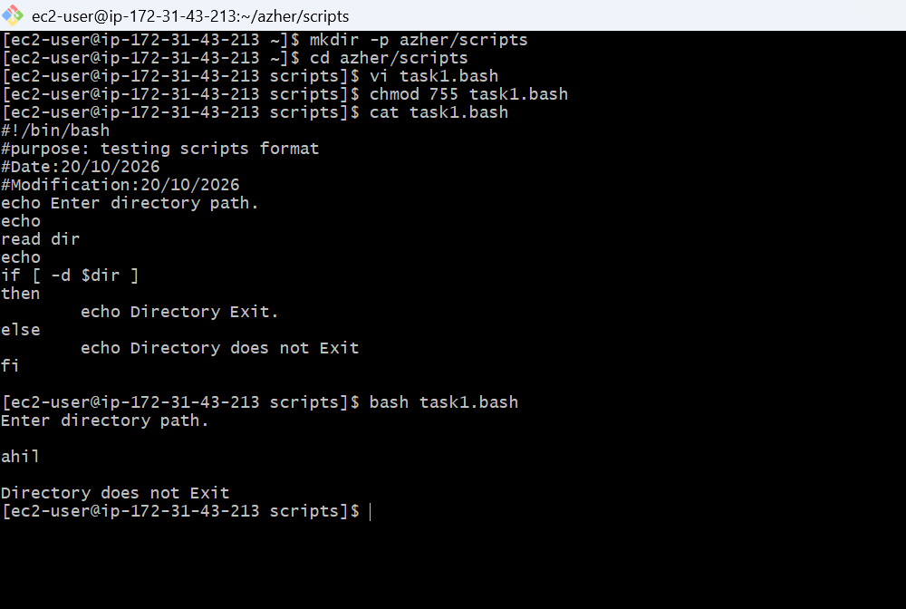

2 . Create a bash script to create multiple files.
Steps
- Created a Bash script named task2.bash.
- Used a for loop with {1..5} to generate five numbers.
- Used the do statement to begin the loop's commands.
- Used touch file$i.txt to create five empty files.
- Used echo to display the name of each created file.
- Used done to terminate the loop.
- Executed the script and verified the files using ls -l file*.txt.
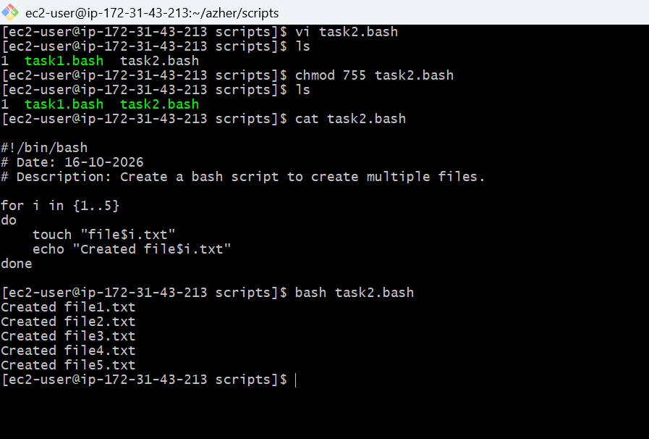
3 . Create a bash script to take a backup of a directory.
Steps
- Created a Bash script named task3.bash.
- Used read to accept the directory path from the user.
- Used if [ -d "$dir" ] to verify that the directory exists.
- Used tar with archive options to package the directory into a backup file.
- Used dirname and basename to identify the parent directory and target directory name.
- Used $? to check the backup command's exit status and display success or failure.
- Verified the generated backup archive and inspected its contents using tar.
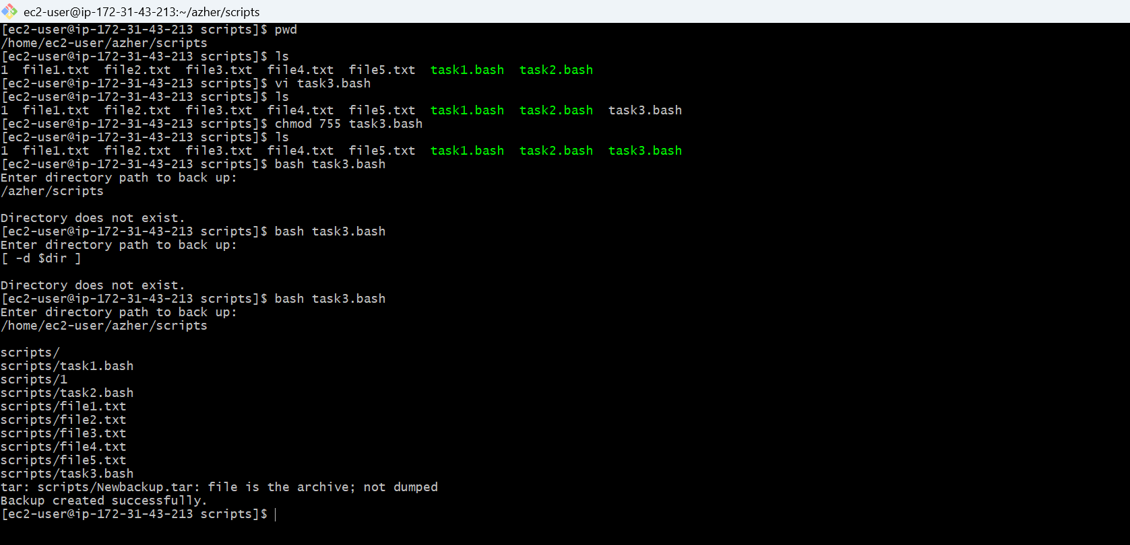
4 . Create a bash script to install Nginx on an EC2 server.

Steps
- Created a Bash script named task4.bash.
- Checked the Linux distribution using /etc/os-release.
- Used case to select the appropriate installation command for the operating system.
- Used dnf install -y nginx for Amazon Linux 2023.
- Used apt-get update and apt-get install -y nginx for Ubuntu.
- Checked the installation result using the command's exit status.
- Started and enabled Nginx using systemctl enable --now nginx, then verified its status.
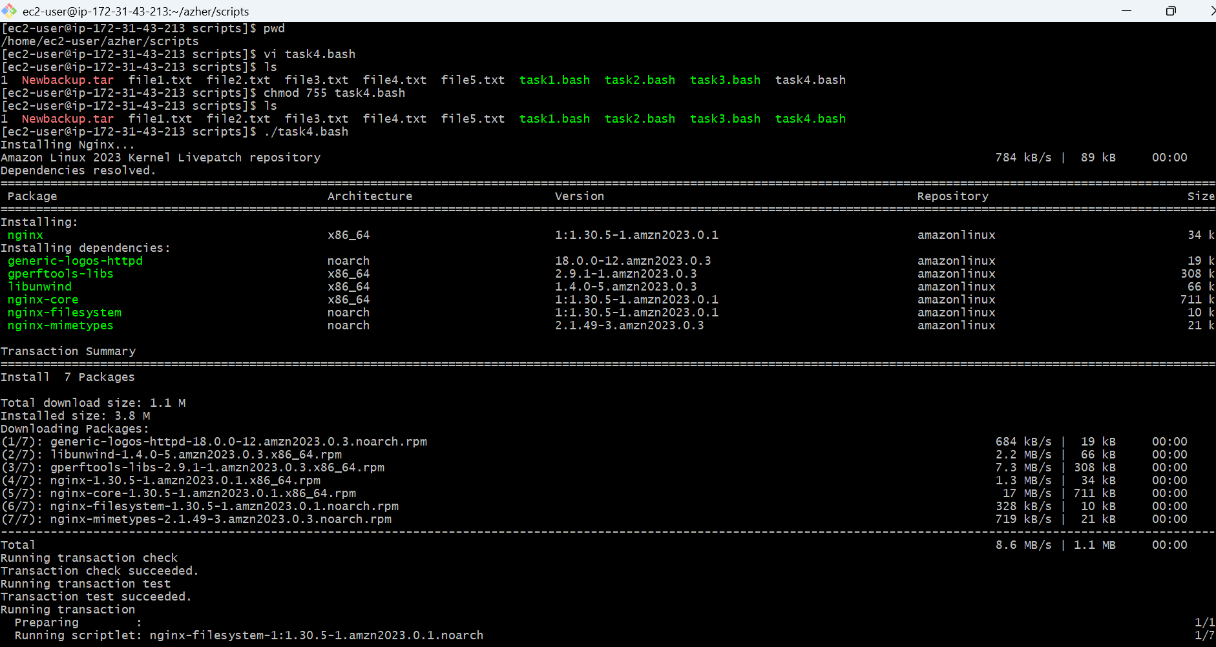
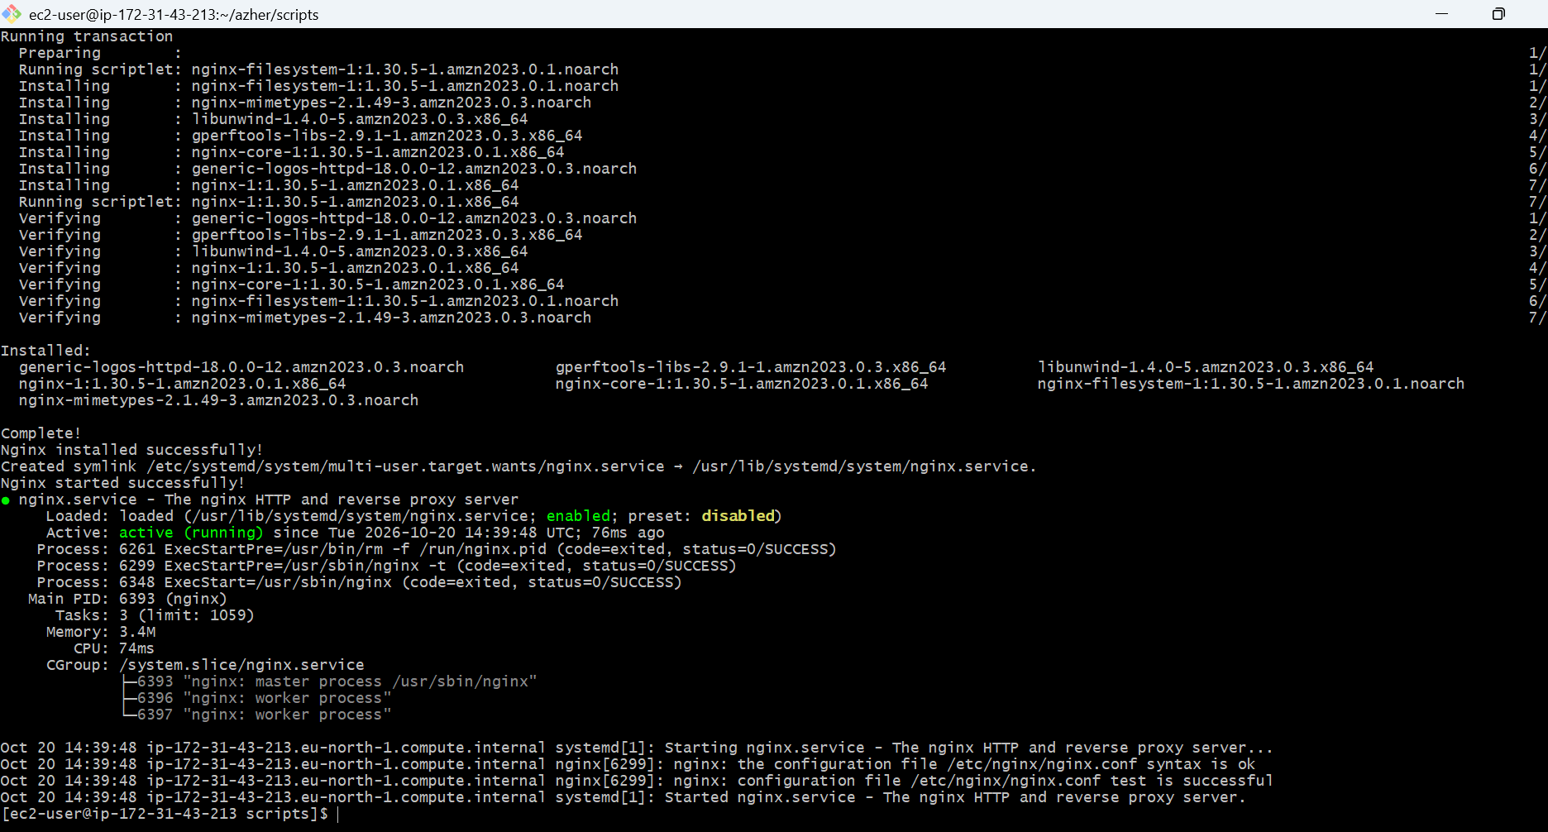
5 . Create a bash script to install Apache Tomcat on an EC2 server.
Steps
- Created a Bash script named task5.bash.
- Checked whether Java was installed using java -version.
- Installed Java 17 using the appropriate package manager when required.
- Checked the Java installation result using exit status conditions.
- Used wget -O to download the Apache Tomcat archive to a specified location.
- Used if and else to display download success or failure messages.
- Verified the Java version and downloaded archive.
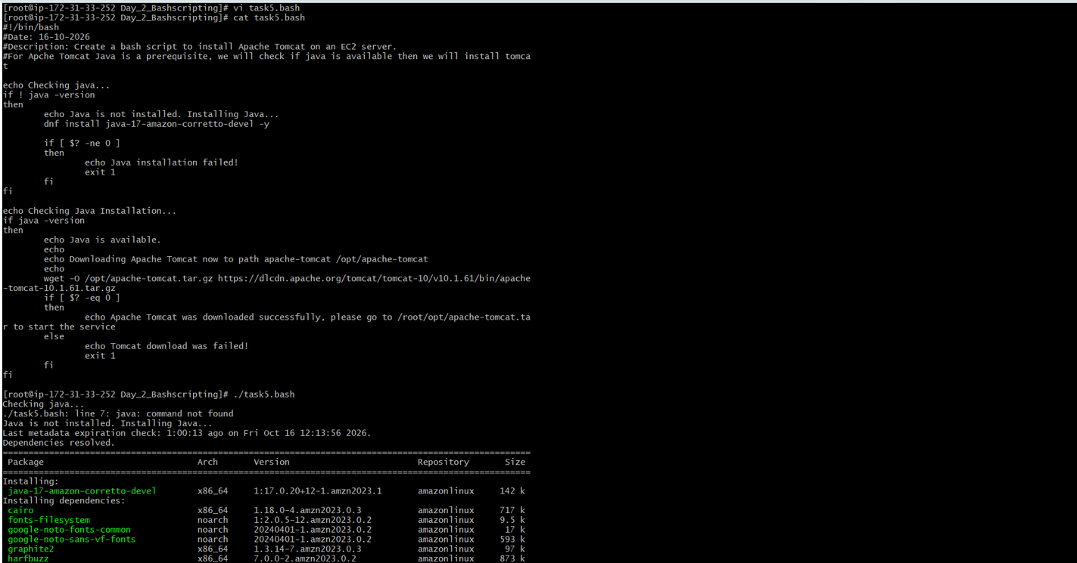
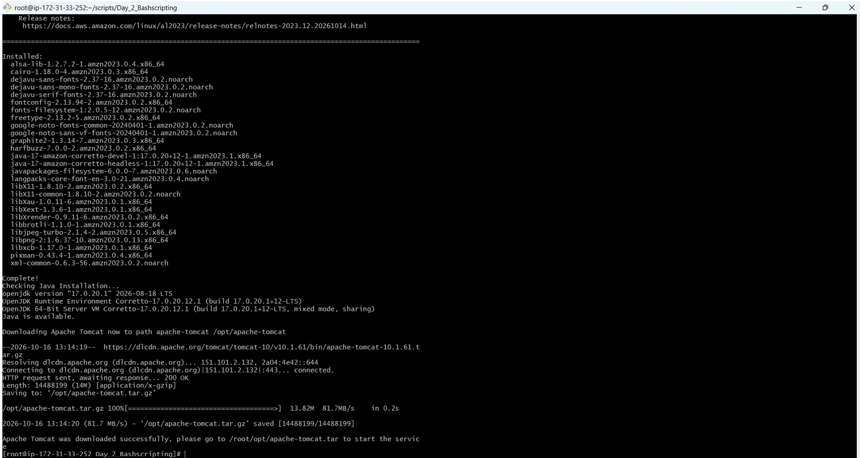
6 . Create a bash script to check if the Nginx service is running, if not running then script should start the service.
Steps
- Created a Bash script named task6.bash.
- Used systemctl is-active --quiet nginx to check the service status.
- Used an if condition to determine whether Nginx was running.
- Displayed a message if Nginx was already active.
- Used systemctl start nginx if the service was stopped.
- Checked the start command's exit status and displayed the result.
- Tested both conditions by stopping Nginx, running the script, and verifying the service status.

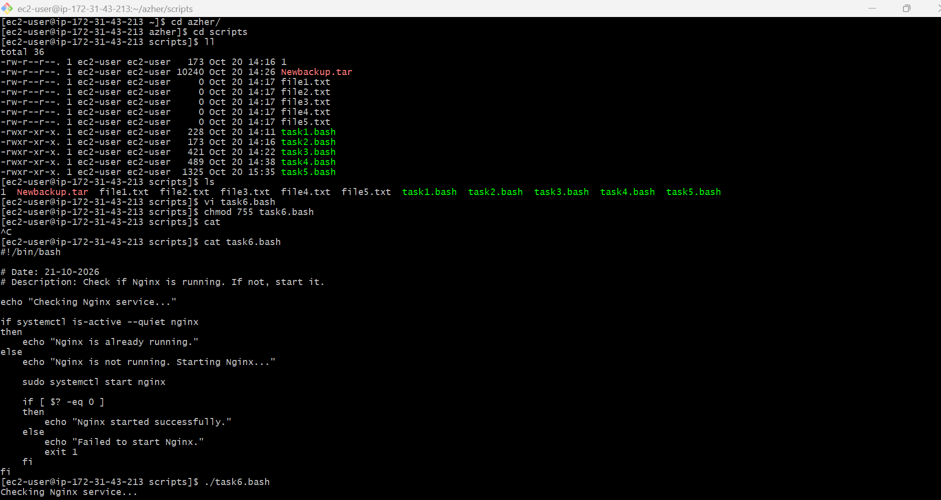
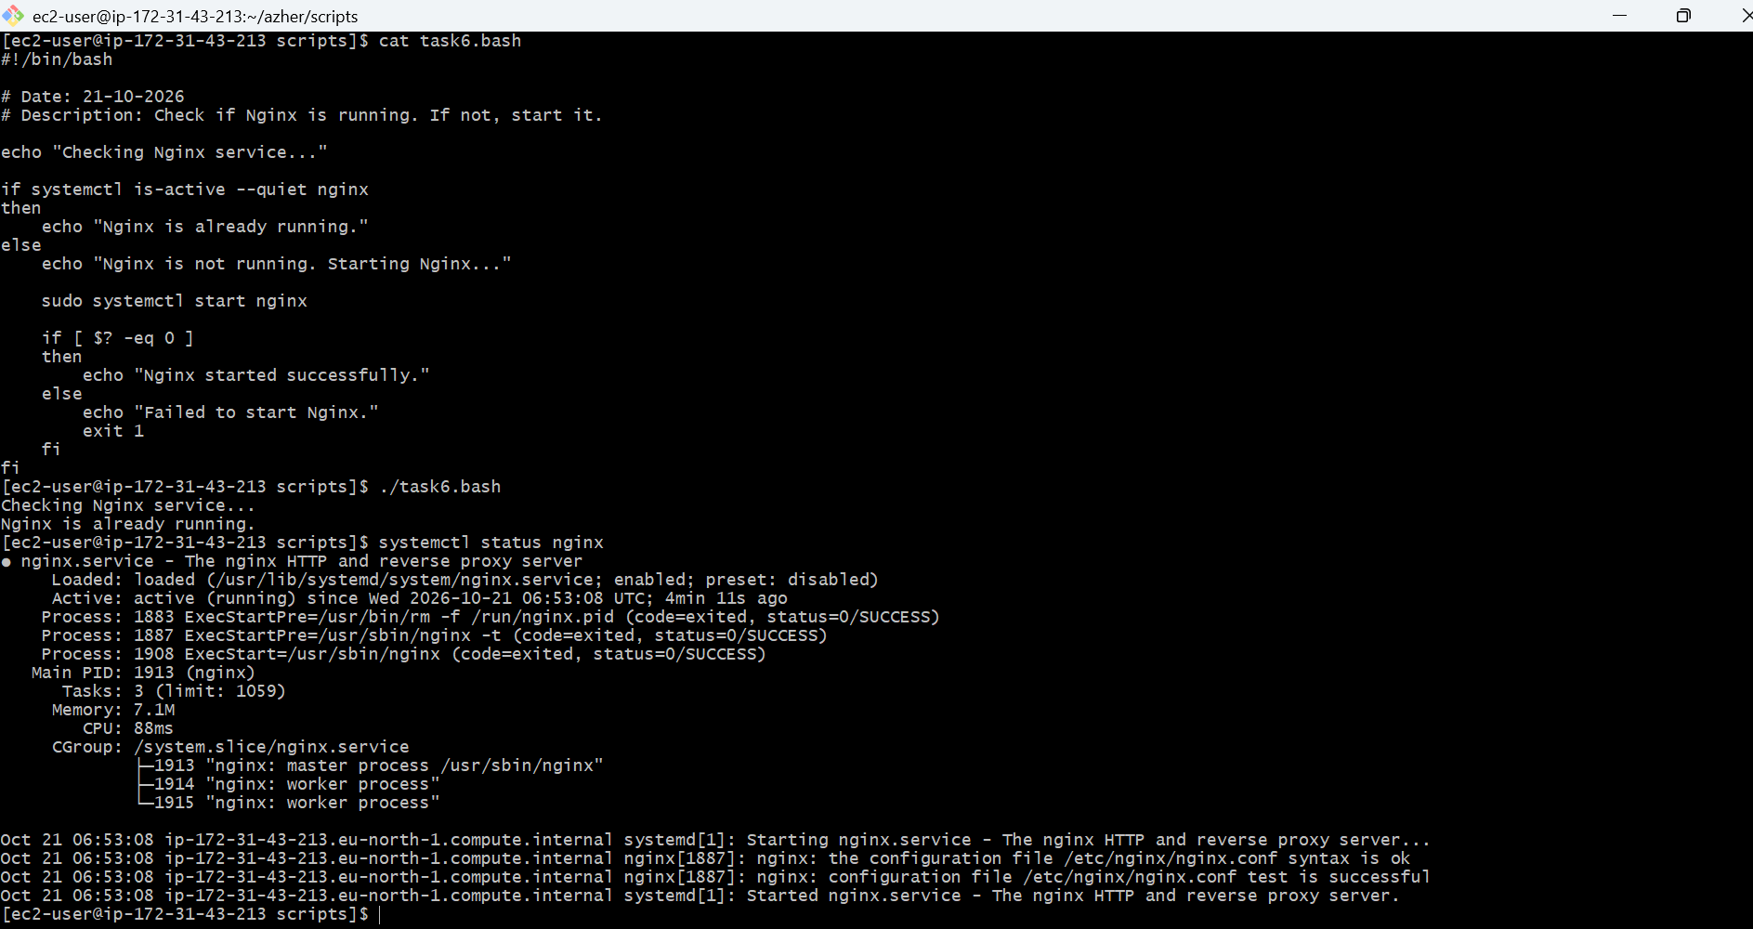
7 . Create a bash script for a calculator.
- Created a Bash script named task7.bash.
- Used read to accept two numbers and an arithmetic operator.
- Stored the inputs in variables.
- Used case to select the appropriate arithmetic operation.
- Used $(( )) to perform addition, subtraction, multiplication, and division.
- Added a condition to prevent division by zero and handled invalid operators.
- Executed the script and tested different calculations.
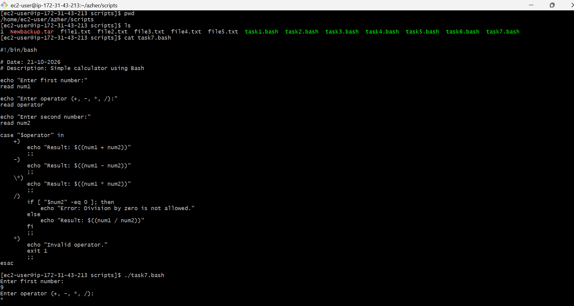
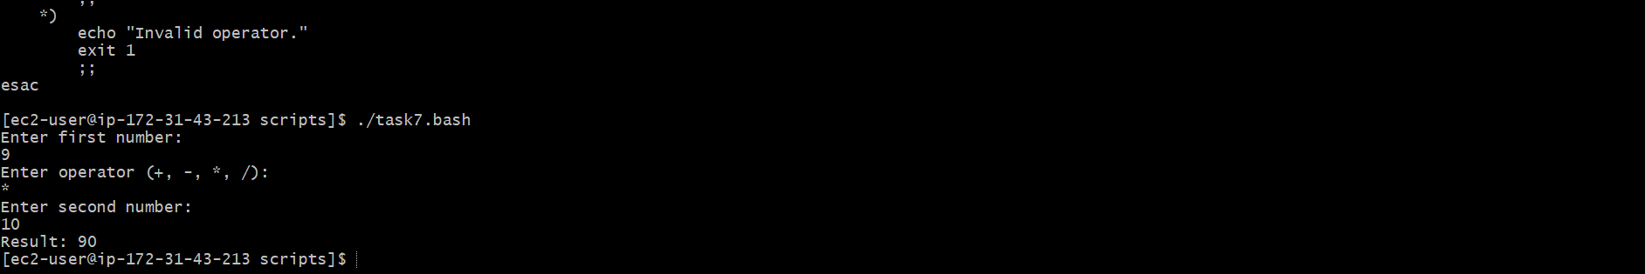

8 . reate a bash script to check if a directory exists, if not then create a directory.
Steps
- Created a Bash script named task8.bash.
- Used read to accept a directory path.
- Used if [ -d "$dir" ] to check whether the directory already existed.
- Displayed a message if the directory was already present.
- Used mkdir -p "$dir" to create the directory when missing.
- Checked the command's exit status to determine whether creation succeeded.
- Ran the script twice and verified both conditions using ls.
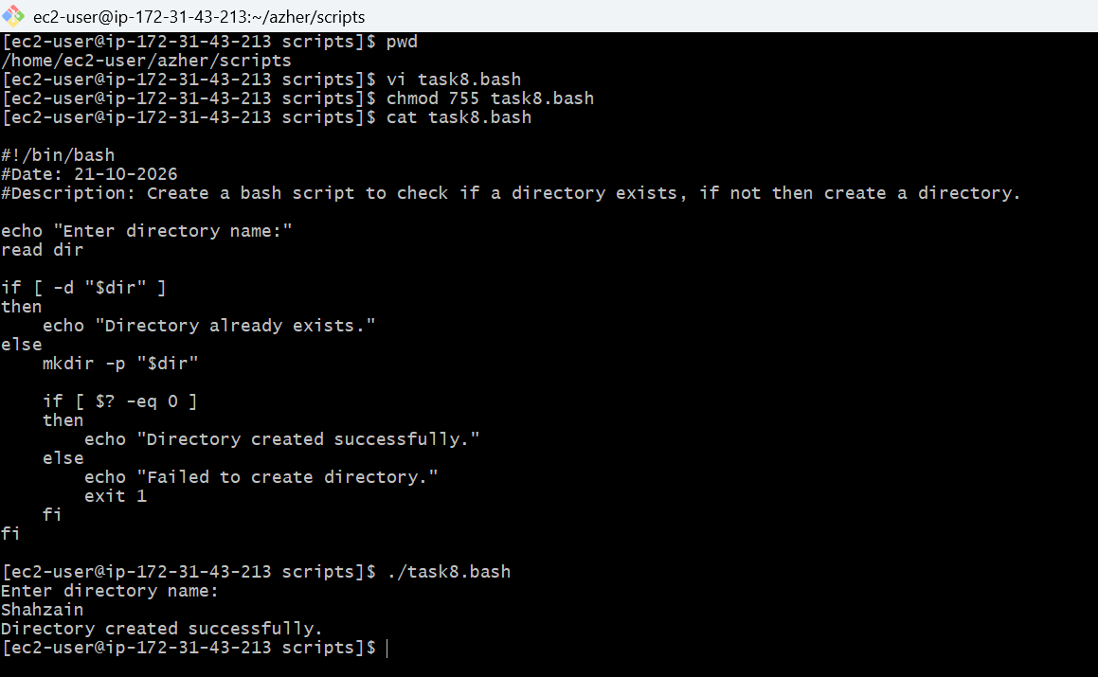
9 . Create a bash script to delete the last 3 lines of a file.
Steps
- Created a test file named number.txt with multiple lines.
- Created a Bash script named task9.bash.
- Used read to accept the filename from the user.
- Used if [ -f "$file" ] to verify that the file existed.
- Used sed -i '$d' "$file" three times to delete the last line on each execution.
- Added success and failure messages using conditional statements and exit status checks.
- Executed the script and used cat number.txt to verify that the last three lines were removed.
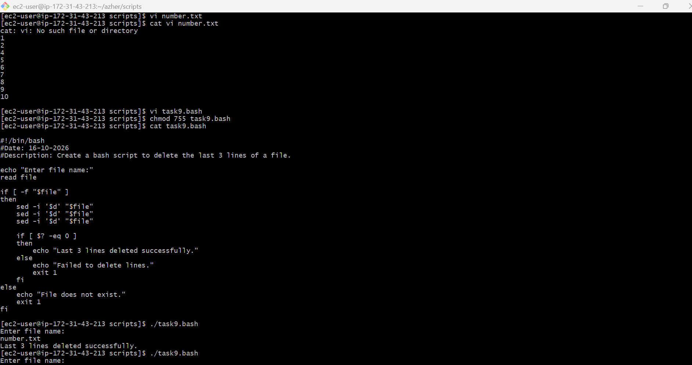
10 . Bash script to monitor cpu and if it is more than 80% then send email notification.
Steps
- Created a Bash script named task10.bash.
- Defined variables for the CPU usage threshold and recipient email address.
- Used a while loop to repeat CPU monitoring continuously.
- Used top, grep, tail, and awk to extract CPU idle time and calculate CPU usage.
- Used an if condition to compare CPU usage against the 80% threshold.
- Used the mail command to attempt to send an email alert when the threshold was exceeded.
- Used sleep 60 to wait one minute between checks and Ctrl + C to stop the script.
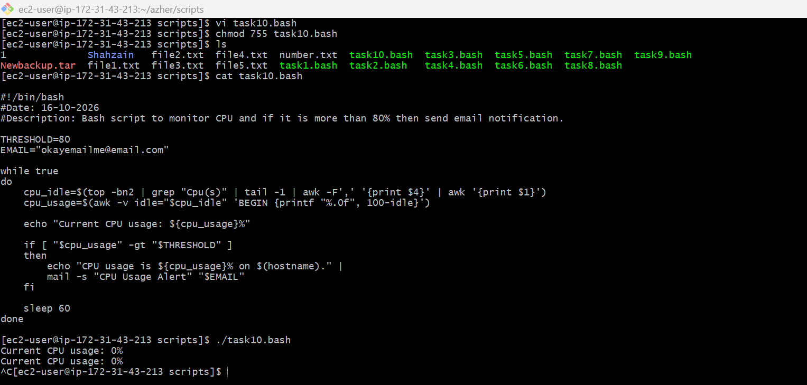
11 . Bash script to monitor disk space and if it is more than 80% then send email notification.
Steps
- Created a Bash script named task11.bash.
- Defined the disk usage threshold and recipient email address.
- Used a while loop to monitor disk usage continuously.
- Used df -P / to retrieve usage information for the root filesystem.
- Used awk to extract the disk usage percentage and remove the % symbol.
- Used an if condition to trigger an email alert when usage exceeded 80%.
- Used sleep 60 to repeat the check every minute and Ctrl + C to stop monitoring.
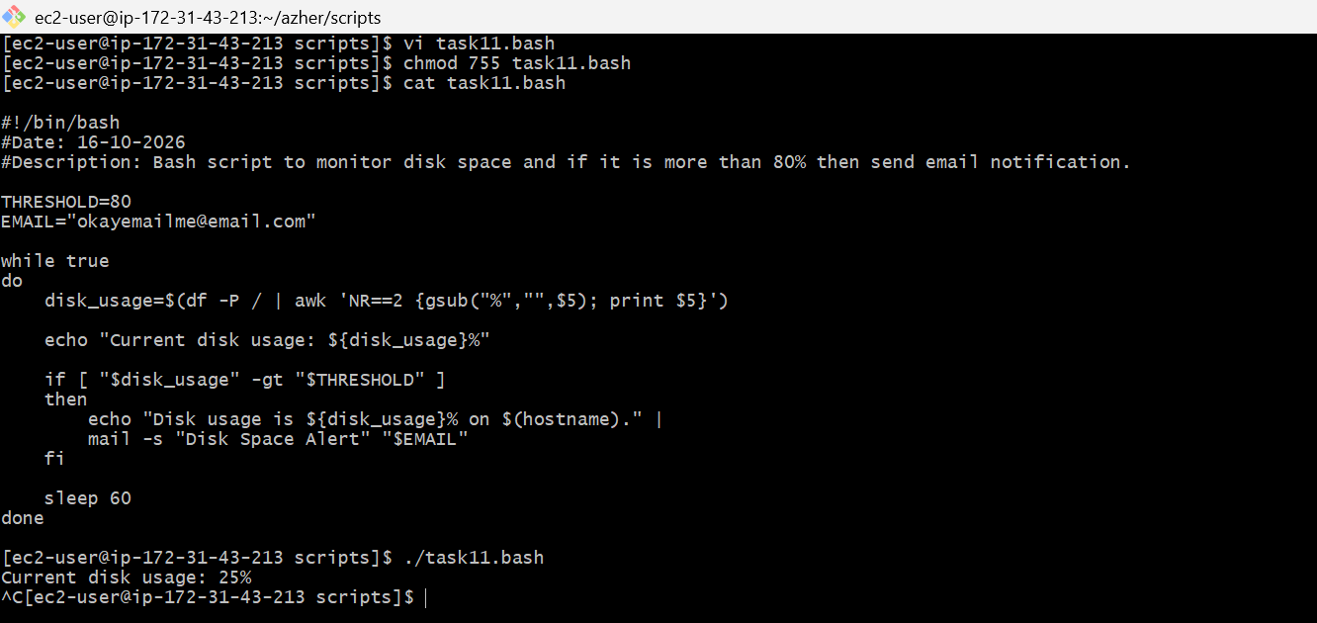

12 . Bash script to monitor memory and if it is more than 80% then send email notification.
Steps
- Created a Bash script named task12.bash.
- Defined the memory usage threshold and recipient email address.
- Used a while loop to monitor memory continuously.
- Read MemTotal and MemAvailable values from /proc/meminfo using awk.
- Calculated memory usage as a percentage of total memory.
- Used an if condition to check whether memory usage exceeded 80% and attempted to send an email alert using mail.
- Used sleep 60 to repeat the check every minute and Ctrl + C to stop the script.
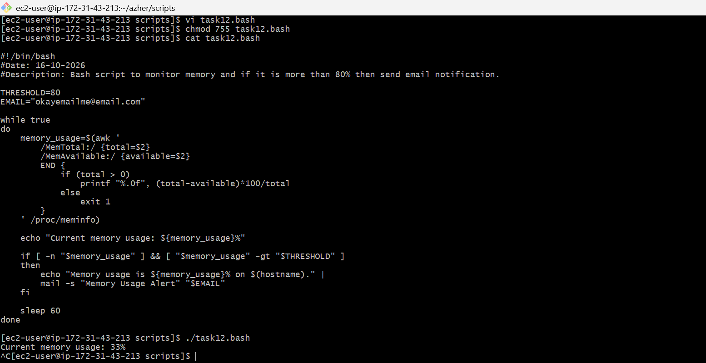

Cronjob Tasks

1: Crontab Entry on April 5th Midnight
Steps
- Opened the crontab using crontab -e to schedule a job.
- Set the minute and hour fields to 0 0 to execute at midnight (12:00 AM).
- Set the day-of-month to 5 and month to 4 (April).
- Used * in the weekday field to allow execution regardless of the day of the week.
- Redirected the output message to /tmp/april5.log using >> to record the execution.
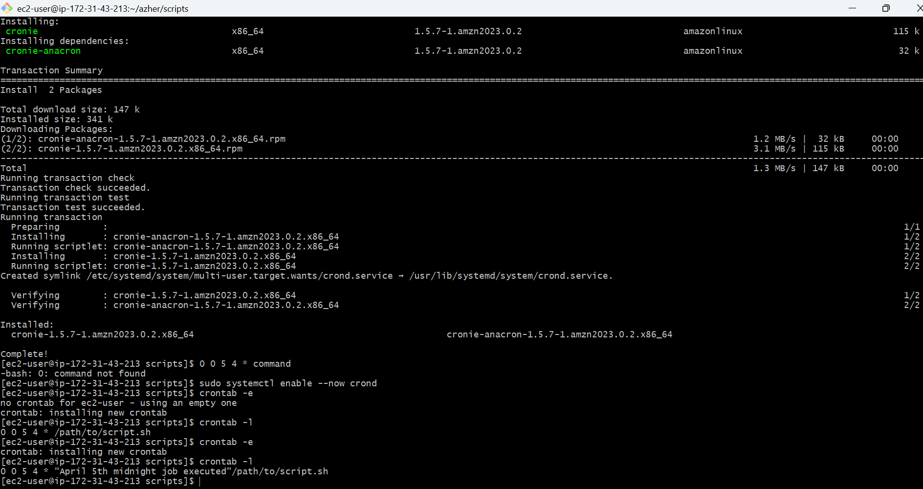

2 . 5th of Every November, January, June if it is a Thursday
Steps
- Opened the crontab using crontab -e to add the second scheduled job.
- Set 0 0 to execute at midnight on the 5th day of the selected months.
- Used 11,1,6 to schedule the job for November, January, and June.
- Used date +\%u to check the weekday number and -eq 4 to verify that the date is Thursday.
- Used && to write the message to /scripyts/task12.bash/task2.log only when the Thursday condition is true.
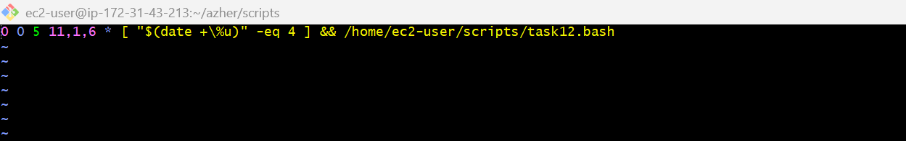
3 . At 05 and 27th minutes of 9, 10, 11 hours every day
Steps
- Opened the crontab using crontab -e to schedule the task.
- Used 5,27 in the minute field to execute at the 5th and 27th minutes.
- Used 9,10,11 in the hour field to schedule the job for 9 AM, 10 AM, and 11 AM.
- Used * * * for day, month, and weekday to run the job every day.
- Redirected the output to /scripts.sh/task3.log using >> to record the execution history.

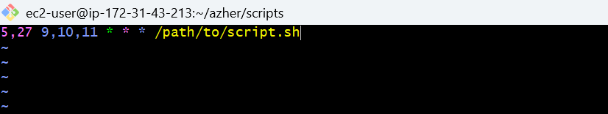
4 . 34 minutes of 9th hour on 15th August
Steps
- Opened the crontab using crontab -e to schedule the task.
- Set the minute field to 34 to execute at the 34th minute.
- Set the hour field to 9, meaning 9:34 AM.
- Set the day-of-month to 15 and month to 8 (August), with * allowing any weekday.
- Redirected the output to /path/to/script.sh/task4.log using >> to record the execution.
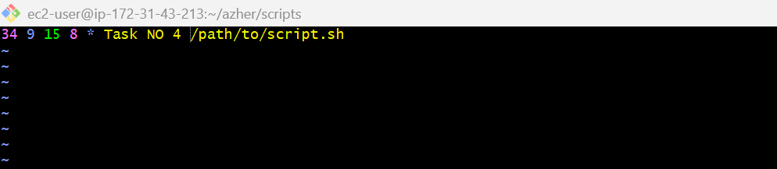
5 . Every midnight
Steps
- Opened the crontab using crontab -e to schedule the job.
- Set the minute field to 0 to execute at the beginning of the hour.
- Set the hour field to 0, meaning midnight (12:00 AM).
- Used * * * for day, month, and weekday to run the job every day.
- Redirected the output to /path/to/script.sh/task5.log using >> to record each execution.
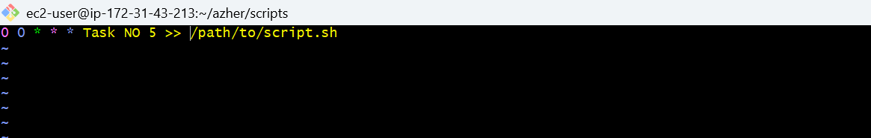
6 . Every Weekend (Saturday night 11:59 PM)
Steps
- Opened the crontab using crontab -e to schedule the job.
- Set the minute field to 59 to execute at the 59th minute.
- Set the hour field to 23, which represents 11 PM in 24-hour format.
- Used * * 6 for day, month, and weekday to run every Saturday. (6 represents Saturday in standard cron.)
- Redirected the output to /path/to/script.sh/task6.log using >> to record each execution.
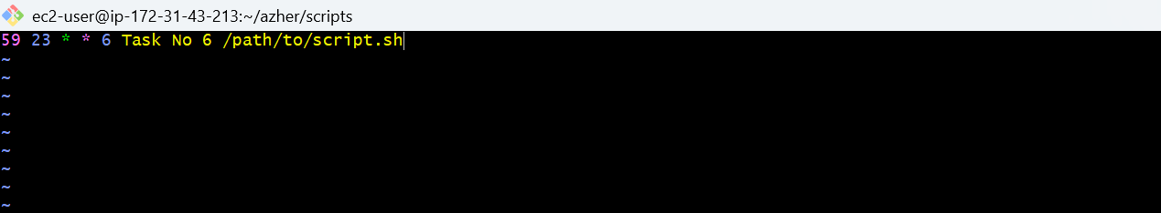
7 . After every reboot
Steps
- Opened the crontab using crontab -e to schedule the job.
- Used the special keyword @reboot to run the command when the cron service starts during system startup.
- Added an echo command to write a message confirming the job execution.
- Redirected the output to /tmp/task7.log using >> to record the message.
- Saved and verified the entry using crontab -l. After rebooting the EC2 instance, checked the log using cat /path/to/script.sh/task7.log.
